Robot Arm 🦾

Robot Arm 🦾 1
References 2
Diagram of Robot Arm 3
Software 3
Parts 3
Motors/Servos 3
Arduino stuff 4
SG90 4
955 or 946 4
Other stuff 4
Nut & Bolts 4
6mm 25 Ball Sphere 5
Other things 5
Controller parts (Not in instructions) 6
Pinouts 7
PICO 7
PICO-Servo-Driver 8
Setup Pico 10
Coding: Motors 10
Hook up SG90 directly on Pico 10
Use Pico-Servo-Driver with MG995 12
Control two MG995’s from Pico-Servo-Driver 14
All three MG995’s off the pico-servo-driver 15
All 4 servos working 17
Use library for servo? 18
servo.py 19
Setup Motors on PICO Servo-Driver 21
Find correct duty for MG995 21
ANSWER 21
Workaround for noisy/chatter motor 21
Assemble 21
Assemble more of the parts 21
[Redundant] Arduino - Hook up Motor controller 21
Controlling ARM 22
Using a POT to control motors 22
Control motors over serial 23
Control LED 23
Control Motor over USB serial 24
Control through a script on PC 25
Work out Think Arm = fail 25
Find sweet spots for motors = REDUNDANT 26
Controlling the Arm 26
Get all motors running 26
Control via IR Remote 27
Print to the shell 27
Capture IR code and print result 27
Use a callback to capture just the data 29
Convert result to printing ‘up,down,left,right’ 30
Control a base motor when using left and right = WORKS!!! 30
Turn motor off = WORKS 32
Strip back and sand each part 33
Adjust robot movements via IR Remote 🎮 33
Capture codes with PICO from spare remote 33
Link codes to motor actions 33
Macros 35
Build a macro 35
Replay it with a button 36
Full listing of code 37
Thin Arm algorithm 40
Table for Algorithm 40
Full listing 41
Power whole thing with 12V 45
ESP32/Arduino with Motor controller 45
Test Motors with ESP32 without library 45
Progress Pictures 48
7/7/2022 49
14/07/2022 53
11/08/2022: Danch measuring the motors AMPS 54
8/09/2022: Controlling with Remote 55
08/11/2022: Finished 57
Conclusion 57
Interesting Finds 57

References
https://projects.raspberrypi.org/en/projects/getting-started-with-the-pico/6

3dprint - https://www.thingiverse.com/thing:1454048
Instructions
- http://www.eezyrobots.it/eba_mk2.html
- https://www.instructables.com/EEZYbotARM-Mk2-3D-Printed-Robot/
- https://www.youtube.com/watch?v=R2MI-tpXyS4

Ruby framework which hooks up to arduino
http://artoo.io/documentation/platforms/arduino/

Diagram of Robot Arm
https://www.instructables.com/EEZYbotARM-Mk2-3D-Printed-Robot/
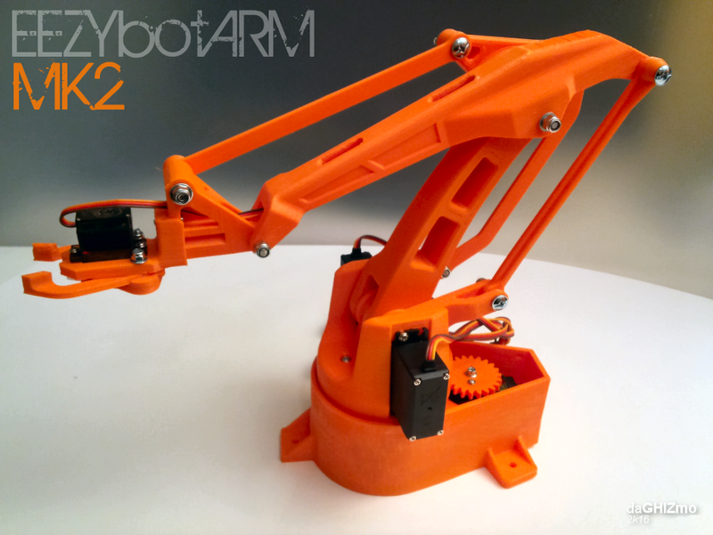

Software
Thonny Python IDE (can use anything, but we started on this)

Parts
3 x MG995 motor
1 x SG90
1 x Pico
1 x motor controller (https://www.waveshare.com/pico-servo-driver.htm)
2 x XC4472 motor controllers (not used)

Links to local parts for the project;

Motors/Servos

Arduino stuff
https://www.jaycar.com.au/arduino-compatible-motor-servo-controller-module/p/XC4472 x 2
https://www.jaycar.com.au/uno-with-wi-fi/p/XC4411

SG90
Quantity: 1

Part | Dimensions | Store | $ | Ordered
Z6392 • 9g 180º 2 x 90º | 22.2 x 11.8 x 31 | Altronics | 10
SG90 9G |  | AusElectronics Direct | 6 | 1 - 9/9/21

955 or 946
Quantity: 3

Part | Dimensions | Store | $ | Ordered
Z6393 • 55g 90º 2 x 45º MG995 | 40.5 x 20 x 41mm | Altronics | 20
MG995 High Speed Digital 12kg | 40 x 19 x 43mm | AusElectronics Direct | 15 | 3 - 9/9/21
Also MG995 now available at Altronics: https://www.altronics.com.au/p/z6393-55g-90deg-metal-servo-for-arduino/

Other stuff

Nut & Bolts

Not included, get these separately later;
n.1 M6 selflocking nut
n.1 M6x25 screw
n.1 M4 x 40 screw
n.1 M4 x 60mm threated rod
n.1 M4 x 32mm threated rod

1080 piece includes;
n.2 M3 selflocking nuts
n.2 M3 x 20 screws
n.1 M3 x 10 hex recessed head screw
n.9 M4 selflocking nuts
n.1 M4 x 30 screw
n.5 M4 x 20 screw

some M4 washers
Part | Store | $
M2,3,4 up to 30 | ebay | 35
1080 piece M2,3,4,5 | Ebay | 18

6mm 25 Ball Sphere

Options;
Part | Store | $ | Delivery
304 Stainless Steel Beads x 100 | ebay | 7 | Dec
6mm Ball Sphere x 30 | ebay | 30 | Oct
Hardened Chrome Steel bearings x 100 | ebay | 8 | Sep

Other things

Part | Store | $
606 ZZ bearing | ebay | 13

Controller parts (Not in instructions)

Part | Store | $
A4988 Motor Controller | Core | 9
Arduino R3 UNO | Altronics | 33
XC4472 Dual motor controller x 2 | Jaycar | 26
XC4411 Arduino with WIFI | Jaycar | 35

If the world was open we could just go to this place;
https://www.minibearings.com.au

Pinouts

PICO
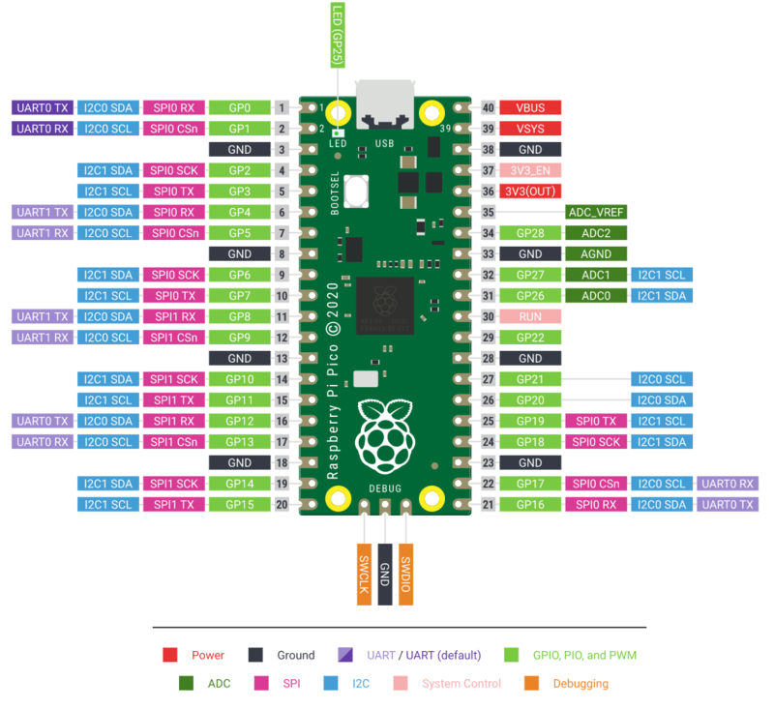

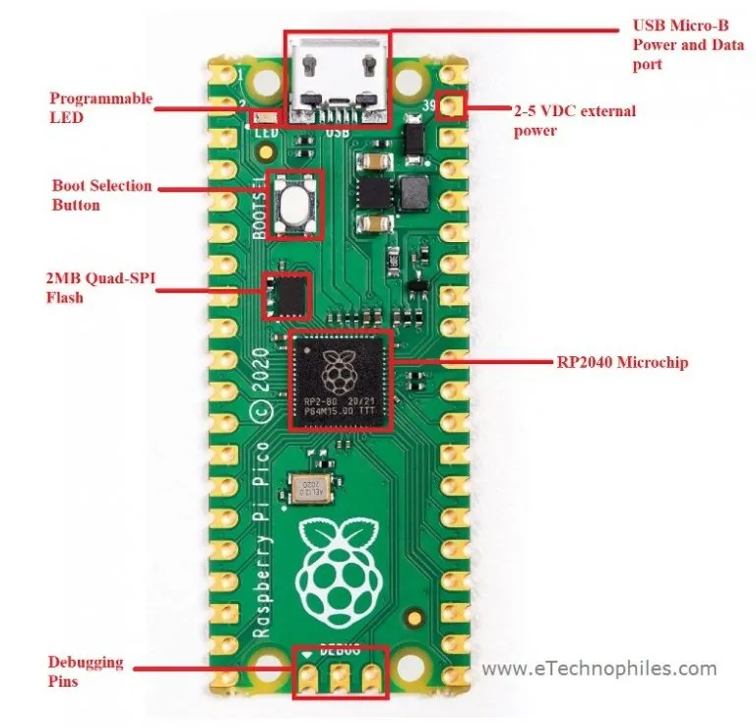
https://www.etechnophiles.com/raspberry-pi-pico-pinout-specifications-datasheet-in-detail/

PICO-Servo-Driver
https://www.waveshare.com/pico-servo-driver.htm

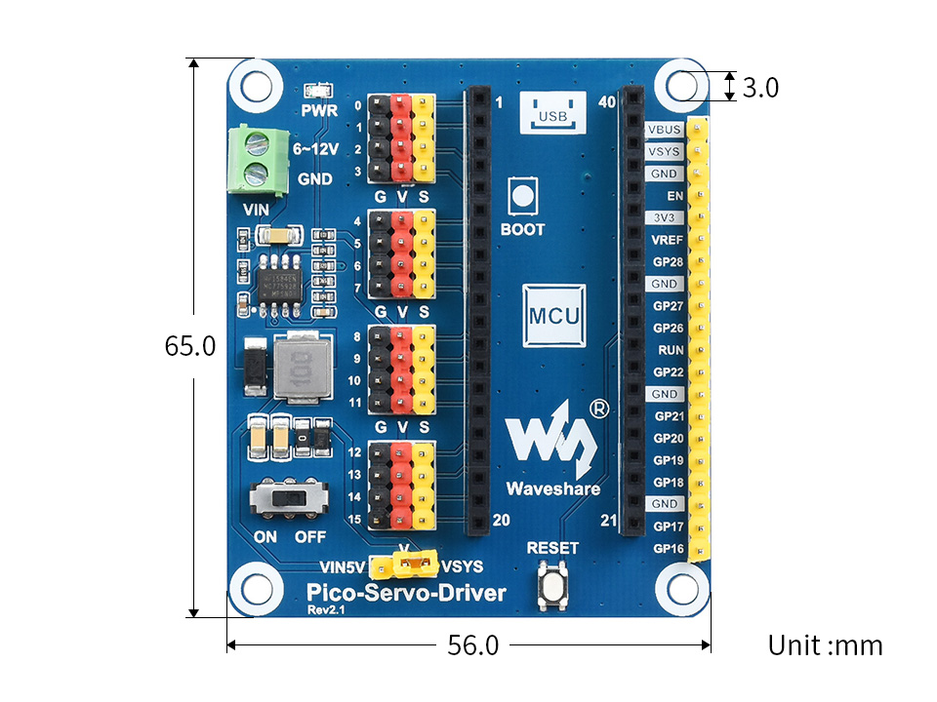

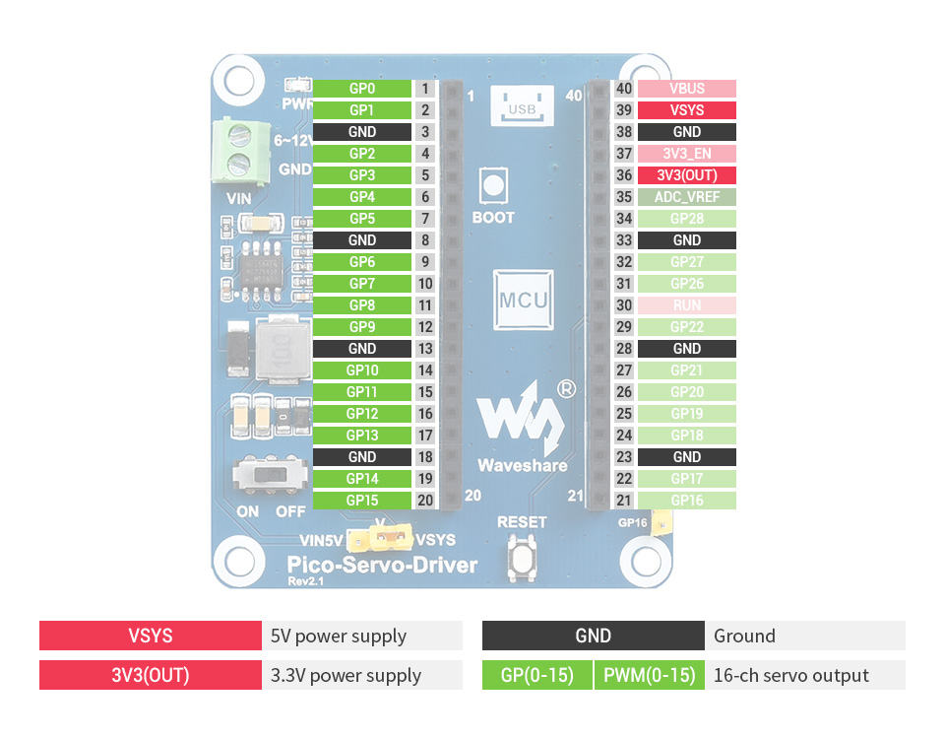

Setup Pico
- Install Thonny on a real machine (ie: Linux)
- Followed guide https://projects.raspberrypi.org/en/projects/getting-started-with-the-pico
https://projects.raspberrypi.org/en/projects/getting-started-with-the-pico/3
- Update microcontroller to the latest micropython
- Testing LED

Coding: Motors

Hook up SG90 directly on Pico

https://peppe8o.com/sg90-servo-motor-with-raspberry-pi-pico-and-micropython/

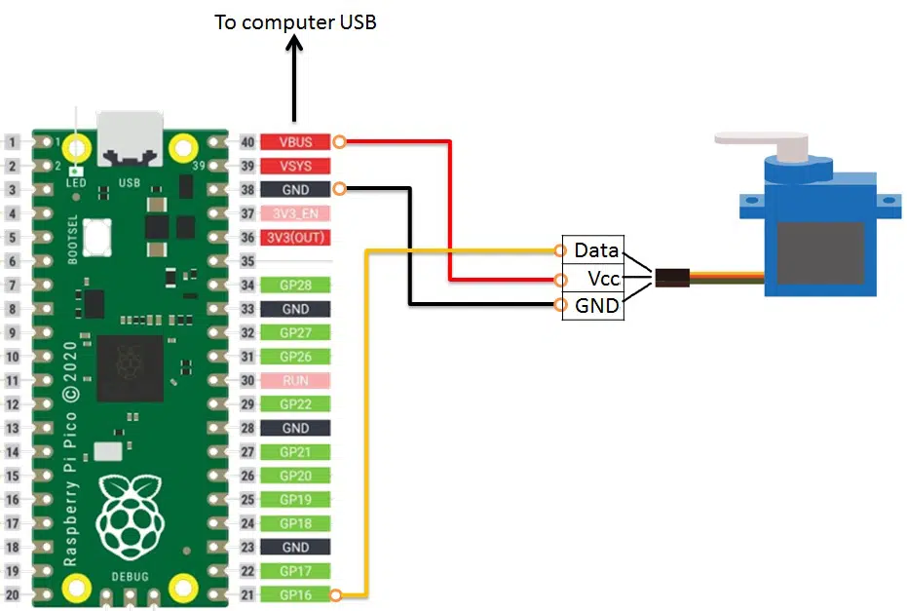

Connect to VBUS for 5V which gets 5V when connected to USB.

# Author: peppe8o
# Blog: https://peppe8o.com
# Date: Jun 3st, 2021
# Version: 1.0
from machine import Pin, PWM
from time import sleep
servoPin = PWM(Pin(16))
servoPin.freq(50) # 50Hz
speed = 0.03
def servo(degrees):
# limit degrees between 0 and 180
if degrees > 180: degrees=180
if degrees < 0: degrees=0
# set max and min duty
maxDuty=9000
minDuty=1000
# new duty is between min and max duty in proportion to its value
newDuty=minDuty+(maxDuty-minDuty)*(degrees/180)
# servo PWM value is set
servoPin.duty_u16(int(newDuty))
while True:
# start increasing loop
for degree in range(0,180,1):
servo(degree)
sleep(speed)
print("increasing -- "+str(degree))
# start decreasing loop
for degree in range(180, 0, -1):
servo(degree)
sleep(speed)
print("decreasing -- "+str(degree))

Use Pico-Servo-Driver with MG995

Device
https://www.waveshare.com/pico-servo-driver.htm

Instructions;
https://www.waveshare.com/wiki/Pico-Servo-Driver

Duty_u16 information;
https://docs.micropython.org/en/latest/library/machine.PWM.html

MG995 pinout
https://microcontrollerslab.com/mg995-servo-motor-pinout-interfacing-with-arduino-features-examples/

- Set jumper to VIN5V to draw power from the external power supply
- Hook up MG995 to PIN 0 on the servo area.
MG995 | Pico Servo Driver
brown | Gnd (black)
red | 5v (red)
orange | Data (yellow)
- Turn on power switch on the Pico-Servo-Driver
- Power pico through USB still
- Create the following in a file called mg995_on_pico_with_servo_class.py
from machine import Pin, PWM
from time import sleep
class Servo:
# these defaults work for the standard TowerPro SG90
__servo_pwm_freq = 50
__min_u16_duty = 1640 + 400 # offset for correction
__max_u16_duty = 7864 - 35 # offset for correction
min_angle = -90
max_angle = 90
current_angle = 0.001
def __init__(self, pin):
self.__initialise(pin)
def update_settings(self, servo_pwm_freq, min_u16_duty, max_u16_duty, min_angle, max_angle, pin):
self.__servo_pwm_freq = servo_pwm_freq
self.__min_u16_duty = min_u16_duty
self.__max_u16_duty = max_u16_duty
self.min_angle = min_angle
self.max_angle = max_angle
self.__initialise(pin)
def move(self, angle):
# round to 2 decimal places, so we have a chance of reducing unwanted servo adjustments
angle = round(angle, 2)
# do we need to move?
if angle == self.current_angle:
return
self.current_angle = angle
# calculate the new duty cycle and move the motor
duty_u16 = self.__angle_to_u16_duty(angle)
self.__motor.duty_u16(duty_u16)
def __angle_to_u16_duty(self, angle):
return int((angle - self.min_angle) * self.__angle_conversion_factor) + self.__min_u16_duty
def __initialise(self, pin):
self.current_angle = -0.001
self.__angle_conversion_factor = (self.__max_u16_duty - self.__min_u16_duty) / (self.max_angle - self.min_angle)
self.__motor = PWM(Pin(pin))
self.__motor.freq(self.__servo_pwm_freq)
#from servo import Servo
pwmPin=0 #change for your pin
motor=Servo(pwmPin)
motor.move(0) # move to 45 degrees
sleep(1)
motor.move(90)
This should move the motor from 0, wait a second and move to 90degrees.

Control two MG995’s from Pico-Servo-Driver

from machine import Pin, PWM
class Servo:
# these defaults work for the standard TowerPro SG90
__servo_pwm_freq = 50
__min_u16_duty = 1640 + 400 # offset for correction
__max_u16_duty = 7864 - 35 # offset for correction
min_angle = -90
max_angle = 90
current_angle = 0.001
def __init__(self, pin):
self.__initialise(pin)
def update_settings(self, servo_pwm_freq, min_u16_duty, max_u16_duty, min_angle, max_angle, pin):
self.__servo_pwm_freq = servo_pwm_freq
self.__min_u16_duty = min_u16_duty
self.__max_u16_duty = max_u16_duty
self.min_angle = min_angle
self.max_angle = max_angle
self.__initialise(pin)
def move(self, angle):
# round to 2 decimal places, so we have a chance of reducing unwanted servo adjustments
angle = round(angle, 2)
# do we need to move?
if angle == self.current_angle:
return
self.current_angle = angle
# calculate the new duty cycle and move the motor
duty_u16 = self.__angle_to_u16_duty(angle)
self.__motor.duty_u16(duty_u16)
def __angle_to_u16_duty(self, angle):
return int((angle - self.min_angle) * self.__angle_conversion_factor) + self.__min_u16_duty
def __initialise(self, pin):
self.current_angle = -0.001
self.__angle_conversion_factor = (self.__max_u16_duty - self.__min_u16_duty) / (self.max_angle - self.min_angle)
self.__motor = PWM(Pin(pin))
self.__motor.freq(self.__servo_pwm_freq)
#from servo import Servo
from time import sleep
pwm0Pin=0 #change for your pin
motor0=Servo(pwm0Pin)
pwm1Pin=1
motor1=Servo(pwm1Pin)
motor0.move(0) # move to 45 degrees
motor1.move(0)
sleep(1)
motor0.move(90)
motor1.move(90)

All three MG995’s off the pico-servo-driver
from machine import Pin, PWM
class Servo:
# these defaults work for the standard TowerPro SG90
__servo_pwm_freq = 50
__min_u16_duty = 1640 + 400 # offset for correction
__max_u16_duty = 7864 - 35 # offset for correction
min_angle = -90
max_angle = 90
current_angle = 0.001
def __init__(self, pin):
self.__initialise(pin)
def update_settings(self, servo_pwm_freq, min_u16_duty, max_u16_duty, min_angle, max_angle, pin):
self.__servo_pwm_freq = servo_pwm_freq
self.__min_u16_duty = min_u16_duty
self.__max_u16_duty = max_u16_duty
self.min_angle = min_angle
self.max_angle = max_angle
self.__initialise(pin)
def move(self, angle):
# round to 2 decimal places, so we have a chance of reducing unwanted servo adjustments
angle = round(angle, 2)
# do we need to move?
if angle == self.current_angle:
return
self.current_angle = angle
# calculate the new duty cycle and move the motor
duty_u16 = self.__angle_to_u16_duty(angle)
self.__motor.duty_u16(duty_u16)
def __angle_to_u16_duty(self, angle):
return int((angle - self.min_angle) * self.__angle_conversion_factor) + self.__min_u16_duty
def __initialise(self, pin):
self.current_angle = -0.001
self.__angle_conversion_factor = (self.__max_u16_duty - self.__min_u16_duty) / (self.max_angle - self.min_angle)
self.__motor = PWM(Pin(pin))
self.__motor.freq(self.__servo_pwm_freq)
#from servo import Servo
from time import sleep
pwm0Pin=0 #change for your pin
motor0=Servo(pwm0Pin)
pwm1Pin=1
motor1=Servo(pwm1Pin)
pwm2Pin=2
motor2=Servo(pwm2Pin)
# Step back and forward loop
while True:
sleep(1)
motor0.move(0) # move to 45 degrees
motor1.move(0)
motor2.move(0)
sleep(1)
motor0.move(90)
motor1.move(90)
motor2.move(90)

All 4 servos working
3 x MG995 and 1 x SG90

from machine import Pin, PWM
class Servo:
# these defaults work for the standard TowerPro SG90
__servo_pwm_freq = 50
__min_u16_duty = 1640 + 400 # offset for correction
__max_u16_duty = 7864 - 35 # offset for correction
min_angle = -90
max_angle = 90
current_angle = 0.001
def __init__(self, pin):
self.__initialise(pin)
def update_settings(self, servo_pwm_freq, min_u16_duty, max_u16_duty, min_angle, max_angle, pin):
self.__servo_pwm_freq = servo_pwm_freq
self.__min_u16_duty = min_u16_duty
self.__max_u16_duty = max_u16_duty
self.min_angle = min_angle
self.max_angle = max_angle
self.__initialise(pin)
def move(self, angle):
# round to 2 decimal places, so we have a chance of reducing unwanted servo adjustments
angle = round(angle, 2)
# do we need to move?
if angle == self.current_angle:
return
self.current_angle = angle
# calculate the new duty cycle and move the motor
duty_u16 = self.__angle_to_u16_duty(angle)
self.__motor.duty_u16(duty_u16)
def __angle_to_u16_duty(self, angle):
return int((angle - self.min_angle) * self.__angle_conversion_factor) + self.__min_u16_duty
def __initialise(self, pin):
self.current_angle = -0.001
self.__angle_conversion_factor = (self.__max_u16_duty - self.__min_u16_duty) / (self.max_angle - self.min_angle)
self.__motor = PWM(Pin(pin))
self.__motor.freq(self.__servo_pwm_freq)
#from servo import Servo
from time import sleep
pwm0Pin=0 #change for your pin
motor0=Servo(pwm0Pin)
pwm1Pin=1
motor1=Servo(pwm1Pin)
pwm2Pin=2
motor2=Servo(pwm2Pin)
pwm3Pin=3
motor3=Servo(pwm3Pin)
# Step back and forward loop
while True:
sleep(1)
motor0.move(0) # move to 45 degrees
motor1.move(0)
motor2.move(0)
motor3.move(0)
sleep(1)
motor0.move(90)
motor1.move(90)
motor2.move(90)
motor3.move(90)

Use library for servo?

https://github.com/sandbo00/picoservo - haven’t tested this yet, might be easier

https://www.digikey.com.au/en/maker/projects/micropython-basics-loading-modules/9560902ac9654f7e91f098e723d097ad

Create two files

servo.py
from machine import Pin, PWM
class Servo:
# these defaults work for the standard TowerPro SG90
__servo_pwm_freq = 50
__min_u16_duty = 1640 + 400 # offset for correction
__max_u16_duty = 7864 - 35 # offset for correction
min_angle = -90
max_angle = 90
current_angle = 0.001
def __init__(self, pin):
self.__initialise(pin)
def update_settings(self, servo_pwm_freq, min_u16_duty, max_u16_duty, min_angle, max_angle, pin):
self.__servo_pwm_freq = servo_pwm_freq
self.__min_u16_duty = min_u16_duty
self.__max_u16_duty = max_u16_duty
self.min_angle = min_angle
self.max_angle = max_angle
self.__initialise(pin)
def move(self, angle):
# round to 2 decimal places, so we have a chance of reducing unwanted servo adjustments
angle = round(angle, 2)
# do we need to move?
if angle == self.current_angle:
return
self.current_angle = angle
# calculate the new duty cycle and move the motor
duty_u16 = self.__angle_to_u16_duty(angle)
self.__motor.duty_u16(duty_u16)
def __angle_to_u16_duty(self, angle):
return int((angle - self.min_angle) * self.__angle_conversion_factor) + self.__min_u16_duty
def __initialise(self, pin):
self.current_angle = -0.001
self.__angle_conversion_factor = (self.__max_u16_duty - self.__min_u16_duty) / (self.max_angle - self.min_angle)
self.__motor = PWM(Pin(pin))
self.__motor.freq(self.__servo_pwm_freq)
def free(self):
self.__motor.duty_u16(0)

Upload servo.py to ‘/’ on PICO.

mg995x3_and_sg90_on_pico_servo_driver_servo_lib_example.py
from servo import Servo
#from servo import Servo
from time import sleep
pwm0Pin=0 #change for your pin
motor0=Servo(pwm0Pin)
pwm1Pin=1
motor1=Servo(pwm1Pin)
pwm2Pin=2
motor2=Servo(pwm2Pin)
pwm3Pin=3
motor3=Servo(pwm3Pin)
# Step back and forward loop
while True:
sleep(1)
motor0.move(0) # move to 45 degrees
motor1.move(0)
motor2.move(0)
motor3.move(0)
sleep(1)
motor0.move(90)
motor1.move(90)
motor2.move(90)
motor3.move(90)

sleep(1)
motor0.free()
motor1.free()
motor2.free()
motor3.free()

Run this file and it should move all four motors. I have three MG995 connected to pin0,1,2 and the SG90 to pin3.

Setup Motors on PICO Servo-Driver
Pin | Motor
0 | Base
1 | Thick Arm
2 | Thin Arm
3 | Claw

Find correct duty for MG995
I think that the min and max duty is affecting the chattering that I’m experiencing.
Angle | Min duty | Max duty | Chattering? | Amps
30 | 1000 | 9000 | n | 0.03
29 | 1000 | 9000 | y | 0.1
31 | 3000 | 6000 | y | 0.1
29 | 3000 | 6000 | y | 0.1
It has nothing to do with the table above.

ANSWER
The plastic is creating force, when there is chatter or a higher Amps then try moving the arm with your hand and it stops chatting and the amps go down to 0.007.

Workaround for noisy/chatter motor
Overshoot by 2 degrees and then return to the value you want to go to.
Example if you are travelling from 50 degrees to 30, then first go to 28 then back to 30.
So it depends on the direction and then use 2 degrees to overshoot.

Assemble

Assemble more of the parts
m4 threaded rod
https://www.minibearings.com.au/store/item/at040m1000m/?v=2194

Michael ordered M4 60mm threaded rod, comes on the 11/07/2022 via Ebay

[Redundant] Arduino - Hook up Motor controller
XC4472 motor controllers

This might be much harder and not worth it as we have the PicoServo-Driver now.

Controlling ARM
We’ve built the arm (see below in the document) and we’ve played around with the motors separately. Now it’s time to apply the logic so we can move the actual arm around and fix any issues as they arrive.

Using a POT to control motors
https://how2electronics.com/how-to-use-adc-in-raspberry-pi-pico-adc-example-code/
https://www.tomshardware.com/how-to/raspberry-pi-pico-ultrasonic-sensor
https://peppe8o.com/how-to-use-a-photoresistor-with-raspberry-pi-pico/
https://stackoverflow.com/questions/1969240/mapping-a-range-of-values-to-another

Hook up
https://how2electronics.com/how-to-use-adc-in-raspberry-pi-pico-adc-example-code/
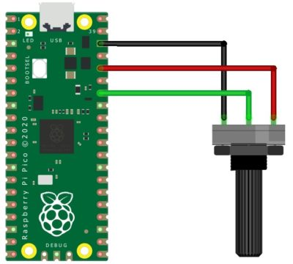
3.3V
GND
GPIO28 (which has Analog Digital Convertor)

Code
from machine import Pin, PWM
from servo import Servo
import utime
pwmPin=0 #change for your pin
motor=Servo(pwmPin)
analog_value = machine.ADC(28)
def translate(value, leftMin, leftMax, rightMin, rightMax):
# Figure out how 'wide' each range is
leftSpan = leftMax - leftMin
rightSpan = rightMax - rightMin
# Convert the left range into a 0-1 range (float)
valueScaled = float(value - leftMin) / float(leftSpan)
# Convert the 0-1 range into a value in the right range.
return rightMin + (valueScaled * rightSpan)
while True:
reading = analog_value.read_u16()
print("ADC: ",reading)
utime.sleep(0.2)
moving = translate(reading, 0, 65536, -90, 90)
print(moving)
motor.move(moving)

At this point we can move the motor with a POT, really handy. It’s a little jerky.

Control motors over serial
https://medium.com/geekculture/serial-connection-between-raspberry-pi-and-raspberry-pico-d6c0ba97c7dc
https://github.com/raspberrypi/pico-examples

Control LED
from machine import Pin
import sys
led = Pin(25, Pin.OUT)
while True:
data = sys.stdin.read(1)
pippo = data[0]
if pippo == "a":
led.on()
else:
led.off()

Then on the PC
$ sudo apt install screen
$ screen /dev/ttyACM0 115200

Then type ‘a’ should turn on the LED and any other character will turn off the LED.
Hit ‘Ctrl+A \’

Another app is ‘minicom’

Control Motor over USB serial
import sys
from machine import Pin, PWM
from servo import Servo
import utime
pwmPin=0 #change for your pin
motor=Servo(pwmPin)
led = Pin(25, Pin.OUT)
position = 0
while True:
data = sys.stdin.read(1)
pippo = data[0]
if pippo == "w":
if position < 90:
position += 10
motor.move(position)
else:
if position > -90:
position -= 10
motor.move(position)

Load this and then use ‘screen /dev/ttyACM0 115200’ and hit w to move and any other key to move back down. This will move the motor the extremes.

Control through a script on PC

On the PC create a python file “motor_usb_serial_server.py”

Then put this code in it;
#!/usr/bin/env python3
import serial
import time
port = serial.Serial("/dev/ttyACM0", 115200)
port.write(b"w")
time.sleep(1)
port.write(b"s")
time.sleep(1)
port.write(b"w")
time.sleep(1)
port.write(b"s")
time.sleep(1)

NOTE: b”w” converts the string to a byte to be sent over the USB.

Then run that
./motor_usb_serial_server.py

Work out Think Arm = fail
Giving the thick arm a workout from -20 to 90 at a fast speed. The idea was to smooth out the movement, but it didn’t work.
direction = 1
count = 80
while 1:
if count == 90 and direction == 1:
direction = -1
elif count == -20:
direction = 1
if direction == 1:
count = count + 1
else:
count = count - 1
print(count)
motor1.move(count)
sleep(0.1)

Find sweet spots for motors = REDUNDANT
https://microcontrollerslab.com/servo-motor-raspberry-pi-pico-micropython/

This is redundant because the problem is the motor is fighting the plastic and not making it to it’s destination.

Find the spots for the main three motors in which they are happy to sit at for long amounts of time without chatting/chatter away.

Maybe the chatter is from the incorrect duty settings?

Explaining https://www.youtube.com/watch?v=NqchLYWHCzA

Controlling the Arm

Get all motors running
from servo import Servo
from time import sleep
pwm0Pin=0 #change for your pin
motor0=Servo(pwm0Pin)
pwm1Pin=1
motor1=Servo(pwm1Pin)
pwm2Pin=2
motor2=Servo(pwm2Pin)
pwm3Pin=3
motor3=Servo(pwm3Pin)
# # Base motor (-90 to 90)
# sleep(1)
# motor0.move(-90) # move to 45 degrees
# sleep(1)
# motor0.move(90)
# sleep(1)
# motor0.move(0)
# Main Arm
motor1.move(40)
sleep(1)
# motor1.move(90)
# sleep(1)
# motor1.move(20)
# sleep(1)
# Pivot Arm (50 to 100 @ main arm 0)
motor2.move(50)
sleep(1)
# # Claw (50 to -53[close])
# motor3.move(50)
# sleep(1)
motor3.move(-53)
sleep(1)
# motor1.move(90)
# motor2.move(90)
# motor3.move(90)

Control via IR Remote

Print to the shell
print("10")

Capture IR code and print result

Receiving high or low
import machine
import time
button = machine.Pin(0, machine.Pin.IN, machine.Pin.PULL_UP)
while True:
first = button.value()
time.sleep(0.01)
second = button.value()
if first and not second:
print('Button pressed!')
elif not first and second:
print('Button released!')

- Hook up your signal to GPIO 16 and get 5V from the servo driver output.
- Install library
https://github.com/peterhinch/micropython_ir/blob/master/RECEIVER.md
$ git clone https://github.com/peterhinch/micropython_ir
Then in thonny upload the ir_rx directory to the PICO (NOTE: I had to cancel the first attempt and try again to get it across).
- Then run this code

File: print_out_IR_code.py
from ir_rx.test import test
test()

- Now hit a button on the remote and you should get something like;
Test for IR receiver. Run:
from ir_rx.test import test
test() for NEC 8 bit protocol,
test(1) for NEC 16 bit,
test(2) for Sony SIRC 12 bit,
test(3) for Sony SIRC 15 bit,
test(4) for Sony SIRC 20 bit,
test(5) for Philips RC-5 protocol,
test(6) for RC6 mode 0.
test(7) for Microsoft Vista MCE.
test(8) for Samsung.
Hit ctrl-c to stop, then ctrl-d to soft reset.
running
Data 0x0a Addr 0x0003 Ctrl 0x00
Repeat code.
Repeat code.
running

Use a callback to capture just the data
import time
from machine import Pin
from ir_rx.nec import NEC_8 # NEC remote, 8 bit addresses
def callback(data, addr, ctrl):
if data < 0: # NEC protocol sends repeat codes.
print('Repeat code.')
else:
print('Data {:02x} Addr {:04x}'.format(data, addr))
ir = NEC_8(Pin(16, Pin.IN), callback)

Convert result to printing ‘up,down,left,right’
import time
from machine import Pin
from ir_rx.nec import NEC_8 # NEC remote, 8 bit addresses
def callback(data, addr, ctrl):
if data > 0: # NEC protocol sends repeat codes.
print('Data {:02x}'.format(data))
if data == 0x0c:
print("UP")
elif data == 0x10:
print("DOWN")
elif data == 0x08:
print("LEFT")
elif data == 0x04:
print("RIGHT")
ir = NEC_8(Pin(16, Pin.IN), callback)

Control a base motor when using left and right = WORKS!!!

File: move_with_remote.py
from servo import Servo
import time
from machine import Pin
from ir_rx.nec import NEC_8 # NEC remote, 8 bit addresses
def free(self):
self.__motor.duty_u16(0)
lastData = 0
pwm0Pin=0 #change for your pin
base=Servo(pwm0Pin)
basePos=0
base.move(basePos)
pwm1Pin=1 #change for your pin
thick=Servo(pwm1Pin)
thickPos=20
thick.move(thickPos)
pwm3Pin=3
claw=Servo(pwm3Pin)
claw.move(-53)
time.sleep(0.4)
free(claw)
free(thick)
free(base)
def callback(data, addr, ctrl):
global basePos, thickPos, lastData
if data < 0:
data = lastData
if data > 0: # NEC protocol sends repeat codes.
print('Data {:02x}'.format(data))
if data == 0x13:
print("RESET")
basePos = 0
base.move(basePos)
thickPos = 20
thick.move(20)
claw.move(-53)
elif data == 0x0c:
print("UP")
thickPos = thickPos + 10
thick.move(thickPos)
elif data == 0x10:
print("DOWN")
thickPos = thickPos - 10
thick.move(thickPos)
elif data == 0x08:
print("LEFT")
if basePos > -90:
basePos = basePos - 10
base.move(basePos)
elif data == 0x04:
print("RIGHT")
if basePos < 90:
basePos = basePos + 10
base.move(basePos)
elif data == 0x5b:
print("OPEN")
claw.move(50)
elif data == 0x5f:
print("CLOSE")
claw.move(-53)
print(basePos)
time.sleep(0.4)
free(claw)
free(base)
free(thick)
lastData = data
ir = NEC_8(Pin(16, Pin.IN), callback)

Turn motor off = WORKS

Ref: https://forum.arduino.cc/t/how-to-turn-off-pwm/368041
digitalWrite(motorPin, LOW);

https://forums.raspberrypi.com/viewtopic.php?t=332255
- Set duty to zero = fail
motor1.duty_u16(0)

- Reinitialise motor PWM pin = fail

motor1=Servo(pwm1Pin)

- Test: Get into chatter, power off, then on again does it still chatter = yes
This test proves that the servo is no quite in it’s position and it keep trying but it doesn’t have enough energy to get into place so it chatters.
- Set 1khz = fail
pwm1=PWM(Pin(pwm1Pin))
pwm1.freq(1000)

- Change over to the M4 50mm = fail

- Test using this library and setting to ‘free’ = WORKS
https://github.com/sandbo00/picoservo/blob/main/servo.py

I put this into the servo.py library
def free(self):
self.__motor.duty_u16(0)

Call it with
sleep(1)
motor1.free

Strip back and sand each part

- Strip back to just the thick arm
- Test with motor for any chatter
- Build up and test each time, sandpaper if necessary

Adjust robot movements via IR Remote 🎮

Capture codes with PICO from spare remote

print_out_IR_code.py
from ir_rx.test import test
test()

Link codes to motor actions

Button | motor | action
up | Thick arm | up
down | Thick arm | down
left | Base | movement left
right | Base | movement right
Channel Up | claw | open
Channel Down | claw | close
? | Thin arm | up
? | Thin arm | down

NOTE: Thick arm movement will affect thin arm movement automatically I think as they work together.

move_with_remote.py
from servo import Servo
import time
from machine import Pin
from ir_rx.nec import NEC_8 # NEC remote, 8 bit addresses
def free(self):
self.__motor.duty_u16(0)
lastData = 0
pwm0Pin=0 #change for your pin
base=Servo(pwm0Pin)
basePos=0
base.move(basePos)
pwm1Pin=1 #change for your pin
thick=Servo(pwm1Pin)
thickPos=20
thick.move(thickPos)
pwm3Pin=3
claw=Servo(pwm3Pin)
clawPos=-53
claw.move(clawPos)
time.sleep(0.4)
free(claw)
free(thick)
free(base)
def callback(data, addr, ctrl):
global basePos, thickPos, clawPos, lastData
if data < 0:
data = lastData
if data > 0: # NEC protocol sends repeat codes.
print('Data {:02x}'.format(data))
if data == 0x13:
print("RESET")
basePos = 0
base.move(basePos)
thickPos = 20
thick.move(20)
claw.move(-53)
elif data == 0x0c:
print("UP")
thickPos = thickPos + 10
thick.move(thickPos)
elif data == 0x10:
print("DOWN")
thickPos = thickPos - 10
thick.move(thickPos)
elif data == 0x08:
print("LEFT")
if basePos > -90:
basePos = basePos - 10
base.move(basePos)
elif data == 0x04:
print("RIGHT")
if basePos < 90:
basePos = basePos + 10
base.move(basePos)
elif data == 0x5b:
print("OPEN")
claw.move(50)
clawPos = 50
elif data == 0x5f:
print("CLOSE")
claw.move(-53)
clawPos = -53
movements = {"base": basePos, "thick": thickPos, "claw": clawPos}
print(f'movements={movements}')
time.sleep(0.4)
free(claw)
free(base)
free(thick)
lastData = data
ir = NEC_8(Pin(16, Pin.IN), callback)

Macros

Build a macro

- When ‘record’ button is pushed on the remote
elsif data == 0x47: # record
print("RECORD")
record = 1

- Collect movements from all four motors
movements = {"base": basePos, "thick": thickPos, "claw": clawPos}
print(f'movements={movements}')

- Create a Hash of movements and store multiple in an array

At the top
movementsArr = []

Add to the global at the top of the callback ←This is a bit hacky using globals.
global movementsArr, basePos, thickPos, clawPos, lastData

Add to movementsArr which is an array defined at the top of the code and I’ve added this to the call back just after printing to the shell. This collects all the movements.
movementsArr.append(movements)
print(f'Array={len(movementsArr)}')

- When stop button is pushed stop recording
elsif data == 0x46: # stop
print("STOP")
record = 0

- Save Array of Hash movements to a JSON file called movements.json

Replay it with a button

- When ‘play’ button is pushed
elsif data == 0x43: # play
print("PLAY")

- Read JSON file movements.json
f=open("movements.json", "r")
data = f.read()
print(f'{data}')
movementsArr=ujson.loads(data)
f.close()

- Step through each hash with a set timing
for move in movementsArr:
print(f'{move["base"]}')

- Move all motors to the saved hash
elif data == 0x43: # play
print("PLAY")
f=open("movements.json", "r")
data = f.read()
print(f'{data}')
movementsArr=ujson.loads(data)
f.close()
print(f'Array={len(movementsArr)}')
# Step through movementsArr
print("Moving")
for move in movementsArr:
print(f'{move["base"]}')
base.move(move["base"])
thick.move(move["thick"])
claw.move(move["claw"])
time.sleep(0.5)
free(claw)
free(base)
free(thick)

Full listing of code

This full listing will record movements and playback using JSON file format!
from servo import Servo
import time
import ujson
from machine import Pin
from ir_rx.nec import NEC_8 # NEC remote, 8 bit addresses
def free(self):
self.__motor.duty_u16(0)
movementsArr = []
lastData = 0
record = 0
pwm0Pin=0 #change for your pin
base=Servo(pwm0Pin)
basePos=0
base.move(basePos)
pwm1Pin=1 #change for your pin
thick=Servo(pwm1Pin)
thickPos=20
thick.move(thickPos)
pwm3Pin=3
claw=Servo(pwm3Pin)
clawPos=-53
claw.move(clawPos)
time.sleep(0.4)
free(claw)
free(thick)
free(base)
def callback(data, addr, ctrl):
global record,movementsArr, basePos, thickPos, clawPos, lastData
if data < 0:
data = lastData
if data > 0: # NEC protocol sends repeat codes.
print('Data {:02x}'.format(data))
if data == 0x13:
print("RESET")
basePos = 0
base.move(basePos)
thickPos = 20
thick.move(20)
claw.move(-53)
elif data == 0x0c:
print("UP")
thickPos = thickPos + 10
thick.move(thickPos)
elif data == 0x10:
print("DOWN")
thickPos = thickPos - 10
thick.move(thickPos)
elif data == 0x08:
print("LEFT")
if basePos > -90:
basePos = basePos - 10
base.move(basePos)
elif data == 0x04:
print("RIGHT")
if basePos < 90:
basePos = basePos + 10
base.move(basePos)
elif data == 0x5b: # channel up
print("OPEN")
claw.move(50)
clawPos = 50
elif data == 0x5f: # channel down
print("CLOSE")
claw.move(-53)
clawPos = -53
elif data == 0x47: # record
print("RECORD")
record = 1
elif data == 0x46: # stop
print("STOP")
record = 0
output = ujson.dumps(movementsArr)
print(f'JSON={output}')
f=open("movements.json","w")
f.write(str(output))
f.close()
movementsArr=[]
elif data == 0x43: # play
print("PLAY")
f=open("movements.json", "r")
data = f.read()
print(f'{data}')
movementsArr=ujson.loads(data)
f.close()
print(f'Array={len(movementsArr)}')
# Step through movementsArr
print("Moving")
for move in movementsArr:
print(f'{move["base"]}')
base.move(move["base"])
thick.move(move["thick"])
claw.move(move["claw"])
time.sleep(0.5)
free(claw)
free(base)
free(thick)
if record == 1:
movements = {"base": basePos, "thick": thickPos, "claw": clawPos}
movementsArr.append(movements)
print(f'Array={len(movementsArr)}')
time.sleep(0.4)
free(claw)
free(base)
free(thick)
lastData = data
ir = NEC_8(Pin(16, Pin.IN), callback)

Thin Arm algorithm
Now that I’ve got all the parts moving with the remote apart from the thin arm it’s time to come up with the algorithm to move the thin arm.

Table for Algorithm
Thick x Thin
Thin Min = 70
Thin Max = 110

 | Thick | Thin
Min | 0 | 50
Max | 80 | 110

Starting position 10 x 50

Thin 1 | Thin 2 | Thin 3 | Thin 4 | Thin 5
10 | 2 | 7 | 0 | 0
60 x 50 | 62 x 60 | 67 x 70 | 73 x 80 | 80 x 90
2 -5 - 6-7

Full listing
~/code/projects/pico/robot_arm/move_with_remote.py

from servo import Servo
import time
import ujson
from machine import Pin
from ir_rx.nec import NEC_8 # NEC remote, 8 bit addresses
def free(self):
self.__motor.duty_u16(0)
movementsArr = []
lastData = 0
record = 0
pwm0Pin=0
base=Servo(pwm0Pin)
basePos=0
base.move(basePos)
pwm1Pin=1
thick=Servo(pwm1Pin)
thickPos=10
thick.move(thickPos)
pwm2Pin=2
thin=Servo(pwm2Pin)
thinPos =50 # 50,60,70,80,90
thin.move(thinPos)
pwm3Pin=3
claw=Servo(pwm3Pin)
clawPos=-53
claw.move(clawPos)
time.sleep(0.4)
free(claw)
free(thin)
free(thick)
free(base)
def callback(data, addr, ctrl):
global record,movementsArr, basePos, thinPos, thickPos, clawPos, lastData
if data < 0:
data = lastData
if data > 0: # NEC protocol sends repeat codes.
print('Data {:02x}'.format(data))
if data == 0x13:
print("RESET")
basePos = 0
base.move(basePos)
thickPos = 10
thick.move(thickPos)
thinPos=50
thin.move(thinPos)
claw.move(-53)
elif data == 0x0c:
print("UP")
thickPos = thickPos + 10
thick.move(thickPos)
print(thickPos)
elif data == 0x10:
print("DOWN")
thickPos = thickPos - 10
thick.move(thickPos)
print(thickPos)
elif data == 0x5a:
print("THIN SHORT")
if thinPos > 50:
thinPos = thinPos - 10
thin.move(thinPos)
else:
print("MIN")
print(thinPos)
elif data == 0x5e:
print("THIN REACH")
if thinPos < 90:
thinPos = thinPos + 10
thin.move(thinPos)
else:
print("MAX")
print(thinPos)
elif data == 0x08:
print("LEFT")
if basePos > -90:
basePos = basePos - 10
base.move(basePos)
elif data == 0x04:
print("RIGHT")
if basePos < 90:
basePos = basePos + 10
base.move(basePos)
elif data == 0x5b: # channel up
print("OPEN")
claw.move(50)
clawPos = 50
elif data == 0x5f: # channel down
print("CLOSE")
claw.move(-53)
clawPos = -53
elif data == 0x47: # record
print("RECORD")
movementsArr=[]
record = 1
elif data == 0x46: # stop
print("STOP")
record = 0
output = ujson.dumps(movementsArr)
print(f'JSON={output}')
f=open("movements.json","w")
f.write(str(output))
f.close()
elif data == 0x43: # play
print("PLAY")
f=open("movements.json", "r")
data = f.read()
print(f'{data}')
movementsArr=ujson.loads(data)
f.close()
print(f'Array={len(movementsArr)}')
# Step through movementsArr
print("Moving")
for move in movementsArr:
print(f'{move["base"]}')
base.move(move["base"])
thick.move(move["thick"])
thin.move(move["thin"])
claw.move(move["claw"])
time.sleep(0.5)
free(claw)
free(thin)
free(base)
free(thick)
if record == 1:
movements = {"base": basePos, "thick": thickPos, "thin": thinPos, "claw": clawPos}
movementsArr.append(movements)
print(f'Array={len(movementsArr)}')
time.sleep(0.4)
free(claw)
free(thin)
free(base)
free(thick)
lastData = data
ir = NEC_8(Pin(16, Pin.IN), callback)

Power whole thing with 12V

Using a 12V 2A brick to the VIN connectors on the pico-servo-driver motor controller this will power the motors. Then I took a lead from +5V to VSYS on the pico and GND to GND next to VSYS on the PICO. Now I can power the whole thing with one 12V brick.

Ref: https://howchoo.com/pi/how-to-power-the-raspberry-pi-pico

ESP32/Arduino with Motor controller
Controlling the motors of the ARM with Arudino/ESP32 to see if we can get over some of the difficulties we were having with the ARM.

Test Motors with ESP32 without library
Move motor with Arduino/ESP32 code without a library.

- Setup ESP32 in Arduino https://www.deviceplus.com/arduino/lets-play-with-esp-wroom-32-on-arduino-environment-construction-setup-led-blinking/

https://randomnerdtutorials.com/installing-the-esp32-board-in-arduino-ide-windows-instructions/

My exact board
https://wiki.keyestudio.com/KS0413_keyestudio_ESP32_Core_Board

Set board type to ESP32 Dev Module

- WIFI scanning code
Special Note: when compile and upload the source code, hold the BOOT button on the ESP32 board until upload well the code.
NOTE: There is no onboard LED on this board (Keyestudio ESP32)
/*
* This sketch demonstrates how to scan WiFi networks.
* The API is almost the same as with the WiFi Shield library,
* the most obvious difference being the different file you need to include:
*/
#include "WiFi.h"
void setup()
{
Serial.begin(115200);
// Set WiFi to station mode and disconnect from an AP if it was previously connected
WiFi.mode(WIFI_STA);
WiFi.disconnect();
delay(100);
Serial.println("Setup done");
}
void loop()
{
Serial.println("scan start");
// WiFi.scanNetworks will return the number of networks found
int n = WiFi.scanNetworks();
Serial.println("scan done");
if (n == 0) {
Serial.println("no networks found");
} else {
Serial.print(n);
Serial.println(" networks found");
for (int i = 0; i < n; ++i) {
// Print SSID and RSSI for each network found
Serial.print(i + 1);
Serial.print(": ");
Serial.print(WiFi.SSID(i));
Serial.print(" (");
Serial.print(WiFi.RSSI(i));
Serial.print(")");
Serial.println((WiFi.encryptionType(i) == WIFI_AUTH_OPEN)?" ":"*");
delay(10);
}
}
Serial.println("");
// Wait a bit before scanning again
delay(5000);
}

- Move motor without library

int servoPin = 3;
void moveToDegree() {
for (int i = 1; i < 20; i++) {
digitalWrite(servoPin, HIGH);
delayMicroseconds(2200);
digitalWrite(servoPin, LOW);
delayMicroseconds(17800);
}

delay(100);

for (int i = 1; i < 20; i++) {
digitalWrite(servoPin, HIGH);
delayMicroseconds(1000);
digitalWrite(servoPin, LOW);
delayMicroseconds(19000);
}
}
void setup() {
pinMode(servoPin, OUTPUT);
moveToDegree();
}
void loop() {
}

https://www.hackatronic.com/how-to-interface-sg90-servo-motor-with-esp32/

NOTE: PIN 3 doesn’t have to be PWM enabled.

PINS

red |  | 5v
black |  | GND
yellow |  | IO3

- Turn off PWM to test chatter cancellation

Progress Pictures

7/7/2022
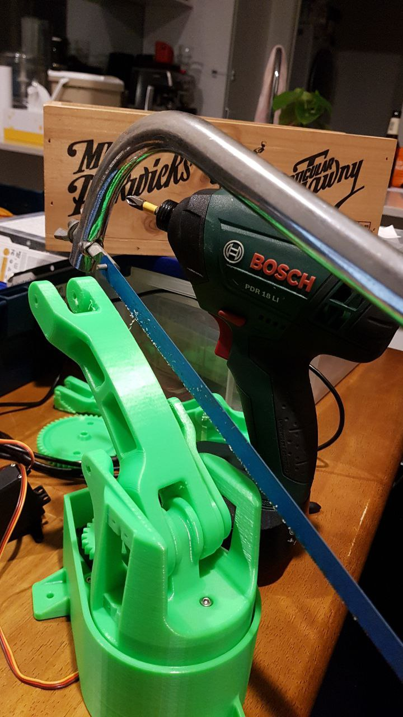

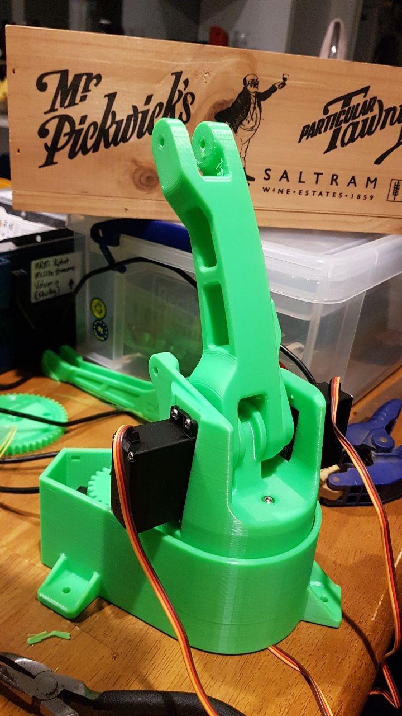

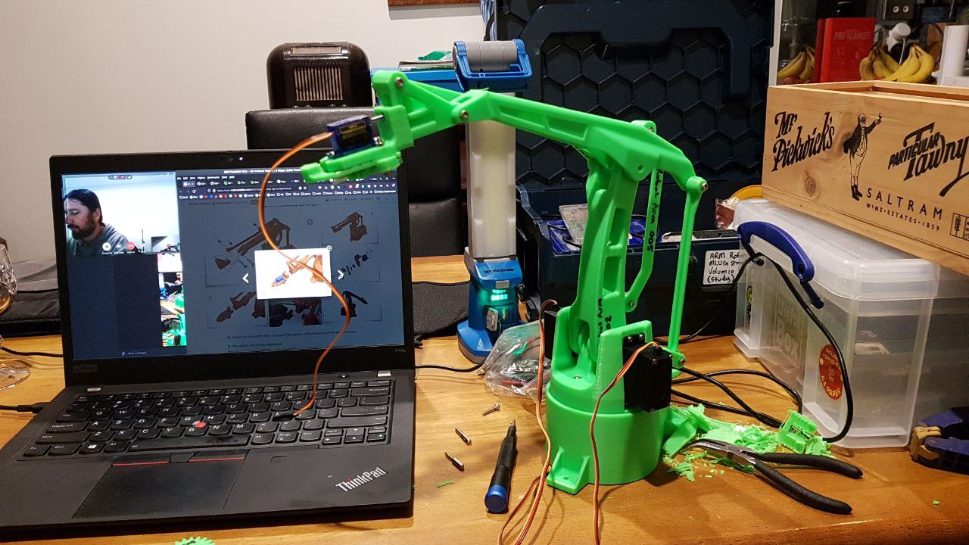

14/07/2022

I get replace by “Rick Allen” the Robot Arm from Def Leppard.
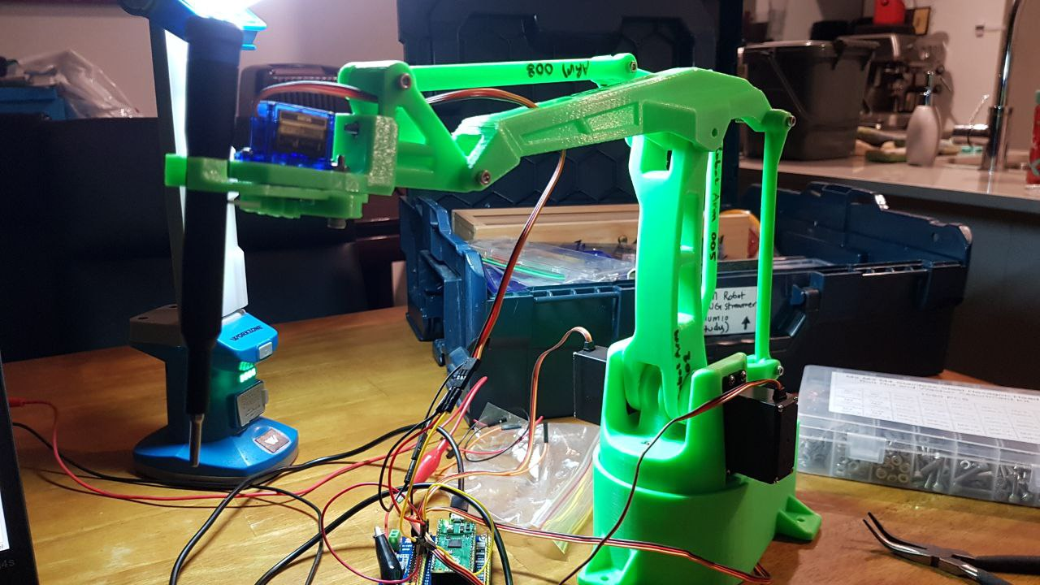

I then start teaching Rick how to play the drums.
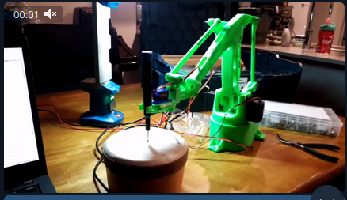

11/08/2022: Danch measuring the motors AMPS
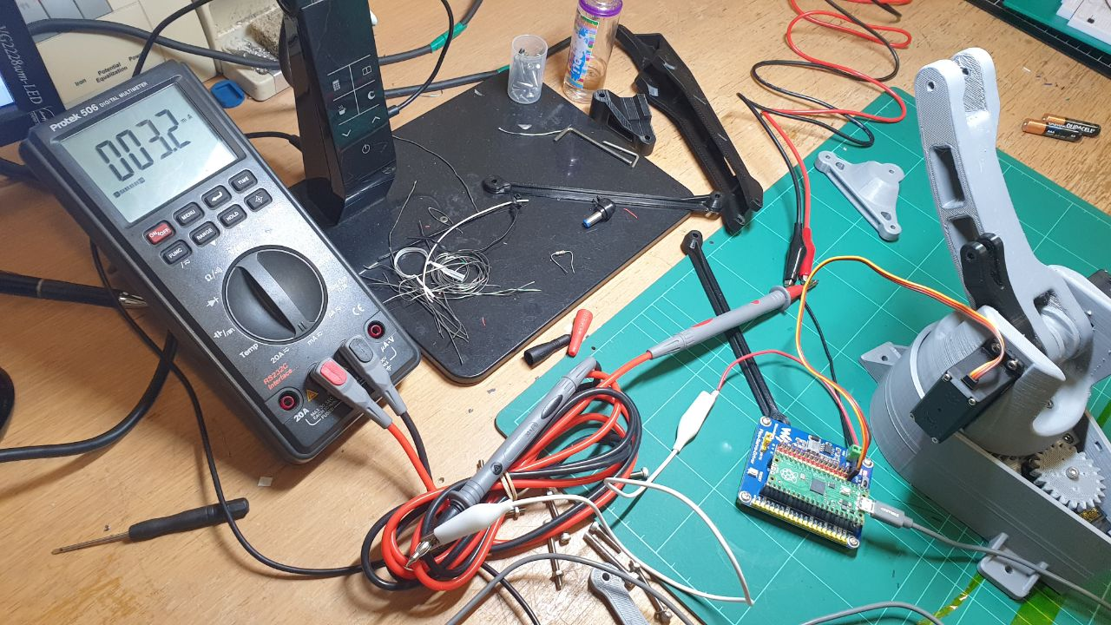

8/09/2022: Controlling with Remote
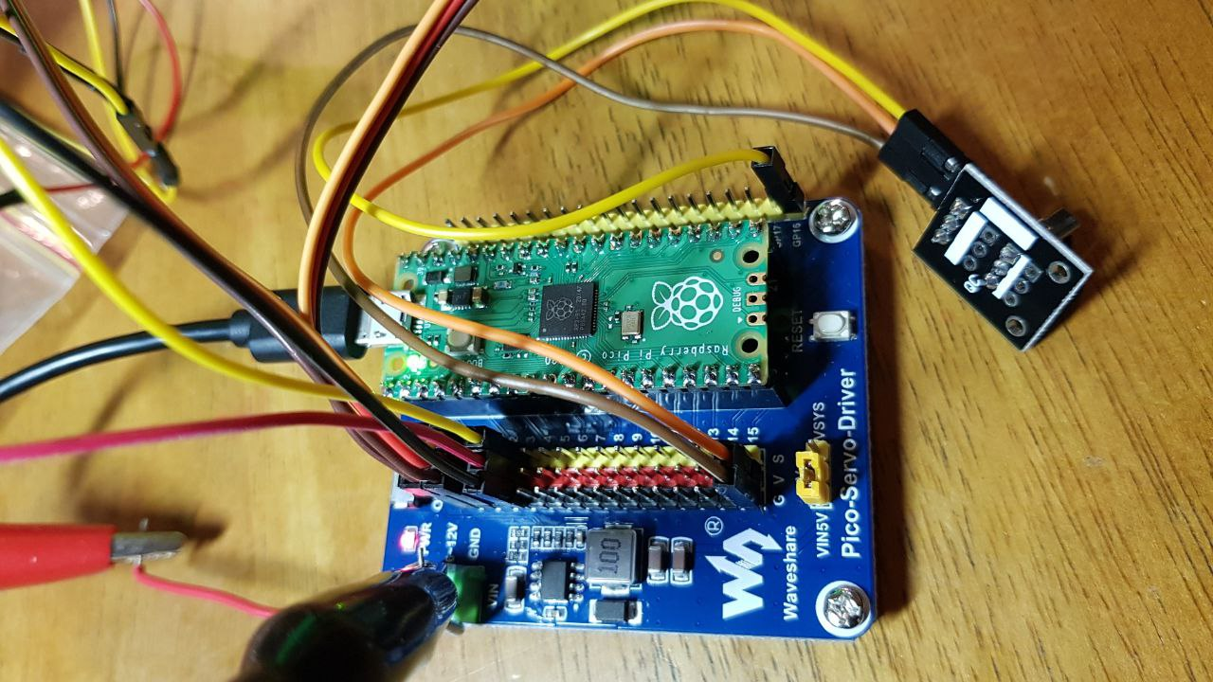

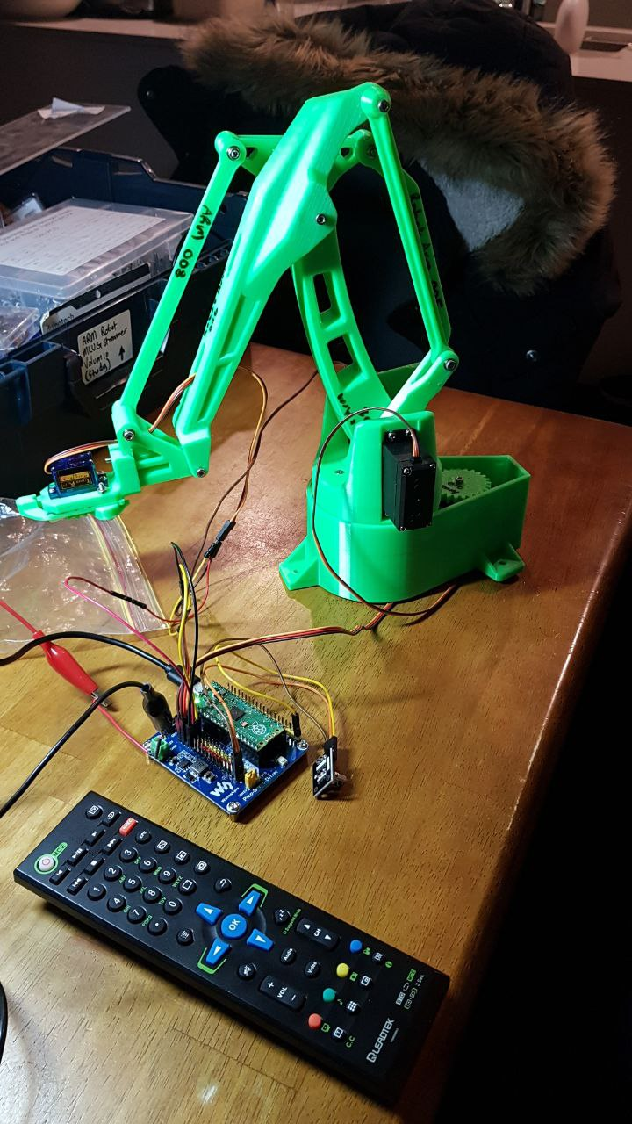

08/11/2022: Finished
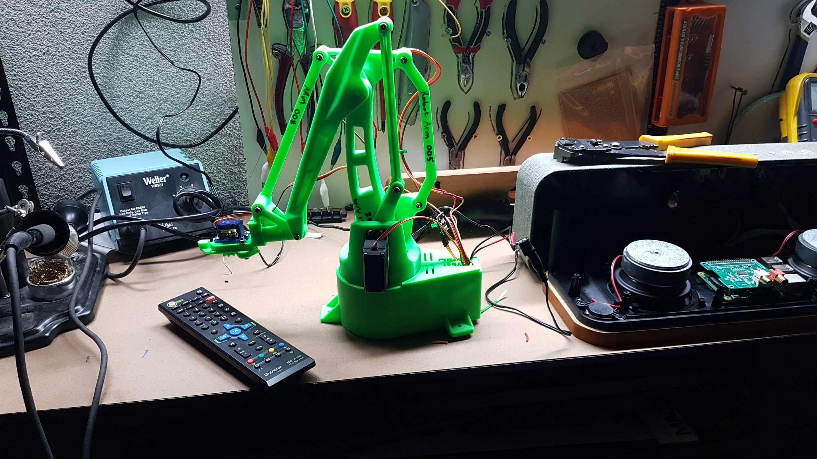
Pico + Motor controller hot glued in the base with all cables routed through the back flap. It’s complete.

Conclusion
Learnt how to control many stepper motors, handle IR codes and create a macro system on the Pico. It was a fun project.

Interesting Finds
https://www.hackster.io/fhdm-dev/use-arduino-libraries-with-the-rasperry-pi-pico-c-c-sdk-eff55c

